Allen Taylor
Name:____________________________

HOMEWORK #1 – Week #1

This homework assignment is worth 10% of your course grade.

Read each problem carefully. Failure to follow the instructions for a problem will result in a zero score for that problem.

Submit the completed Homework via Assignment in LEO

1. How many milliseconds (ms) are in one second? _________

1000

2. How many microseconds (us) are in one second? _________

1000000

3. How many bytes are in 20 megabytes? _________

20000000

- Convert the number below from a binary number to a hexadecimal number
1001101011011.01111

0001 0011 0101 1011. 0111 1000
1 3 5 B. 7 8

5. Convert the number below from a binary number to a decimal number.
10000000110.011
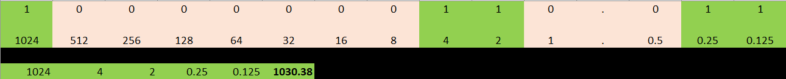

1030.375

6. Convert the hexadecimal number below to a binary number
89A.0C
1000 1001 1010. 0000 1100

7. What is the decimal equivalent of the IEEE 754 binary floating point number shown below?
0 1000 0001 0110 0000 0000 0000 0000 000

0 10000001 01100000000000000000000
10000001 = 129 - 127 = 2^3
-Add up the mantissa binary bits
0 1 1
0 + .25 + .125 = .375
(1 + .375) * 2^3 -> Add 1 to the mantissa decimal value and multiple by the exponent
1.375 * 2^3 = 11
or
1.011 -> Add 1 to the mantissa, then move 3 decimal points to the right
1011 -> Convert binary value to decimal
8 + 0 + 2 + 1 = 11

For problems 8, 9 and 10, convert the following decimal numbers into 8-bit binary numbers as required for 2's complement math, and perform the indicated operations. Circle or bold your binary answer and show your work.
Notes:
- Remember that positive numbers are represented in sign-magnitude format in 2's complement math

8.
+38
+30
=

00100110
00011110

1 1 1 1 1
0 0 1 0 0 1 1 0
+ 0 0 0 1 1 1 1 0
-----------------
0 1 0 0 0 1 0 0 = 68

9.
+38
- 30
=

00100110
00011110 = 11100001 + 1 = 11100010

1 1 1 1
0 0 1 0 0 1 1 0
+ 1 1 1 0 0 0 1 0
-----------------
0 0 0 0 1 0 0 0 = 8
-The remaining 1 is dropped.

10.
- 38
+30
=

00100110 = 11011001 + 1 = 11011010
00011110
1 1 1 1
1 1 0 1 1 0 1 0
+ 0 0 0 1 1 1 1 0
-----------------
1 1 1 1 1 0 0 0 = 11111000 = 00001000 = 8 (-8)
-Starting from the right, go left until hitting the first 1
-All bits to the right of the 1 stay the same
-All bits to the left of the 1 invert
11111000 = 00001000 = 8

